**NETWORK SECURITY FUNDAMENTALS LABORATORY WORK PART 1**

Family Name: David Selvam

Given Name: Visahl Samson

Student Number: 10498743

Unit code and Title: CSI3207 Network Security Fundamentals

Name of Lecturer: Loh Kah Yee

Campus: PSB Academy, Singapore

Course: Bachelors of Science in Cyber Security (FT)

Due Date: 23rd September 2019

Contents

Step 1 Creating Client VM 2

Step 2 creating server VM 12

For this laboratory work purpose, I have chosen Kali Linux as client VM and Ubuntu as server VM. For virtualization environment purpose I have used VMware Workstation 15 Pro which was downloaded with ECU student credentials. The ISO files has been downloaded from their respective official sites.

# Step 1 Creating Client VM

Here, I have chosen Kali Linux as my client VM. Screenshots of step by step installation process has been provided.

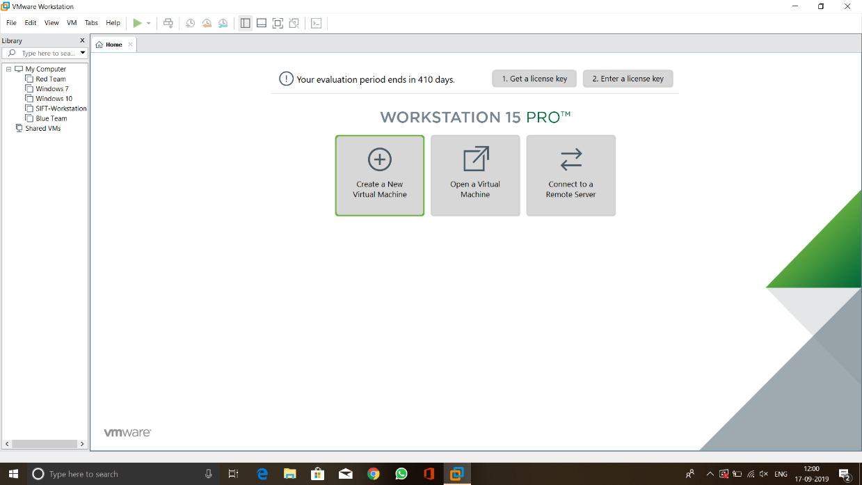

Figure VMware Workstation Homepage

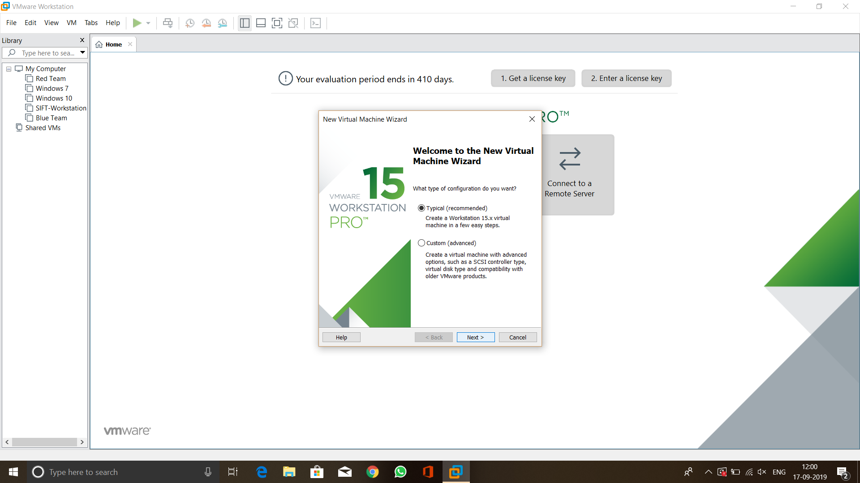Figure 1 represents the VMware workstation homepage. In the home page I have used the option **“Create a New Virtual Machine”** in order to install a new Virtual Machine.

Figure Installation method

Once, I have selected the “Create a New Virtual Machine” option, it displayed the installation method type option to choose type of installation there I have selected **“typical (recommended)”** option. This step has been given in Figure 2.

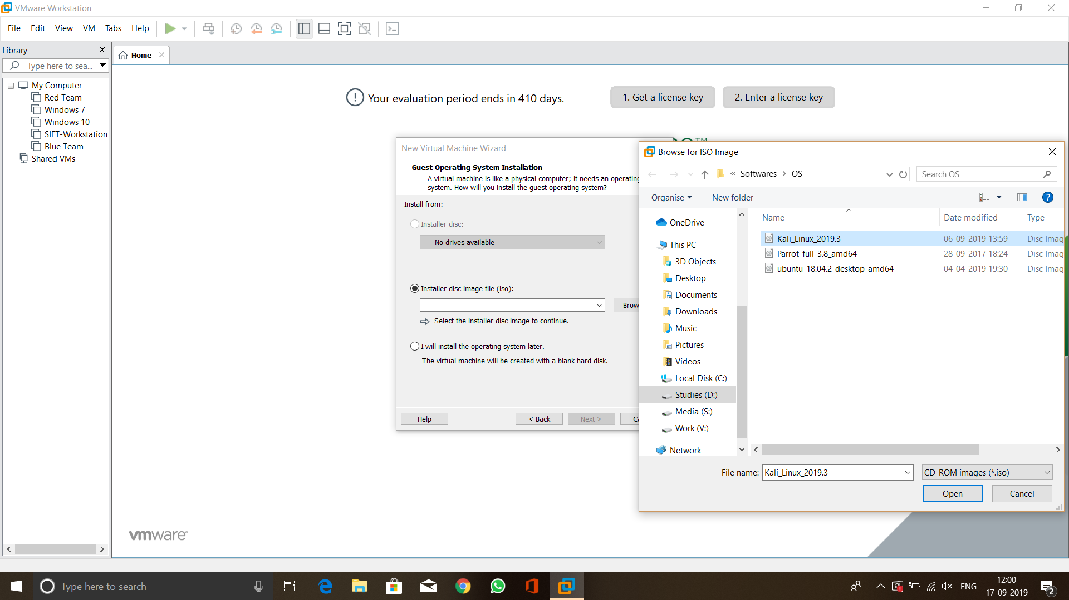

Figure Selecting ISO file

Once the installation type has been selected then I had selected the ISO file to start the installation process. Here, I have browsed the ISO file destination folder and selected Kali Linux ISO file. This step has been given in Figure 3.

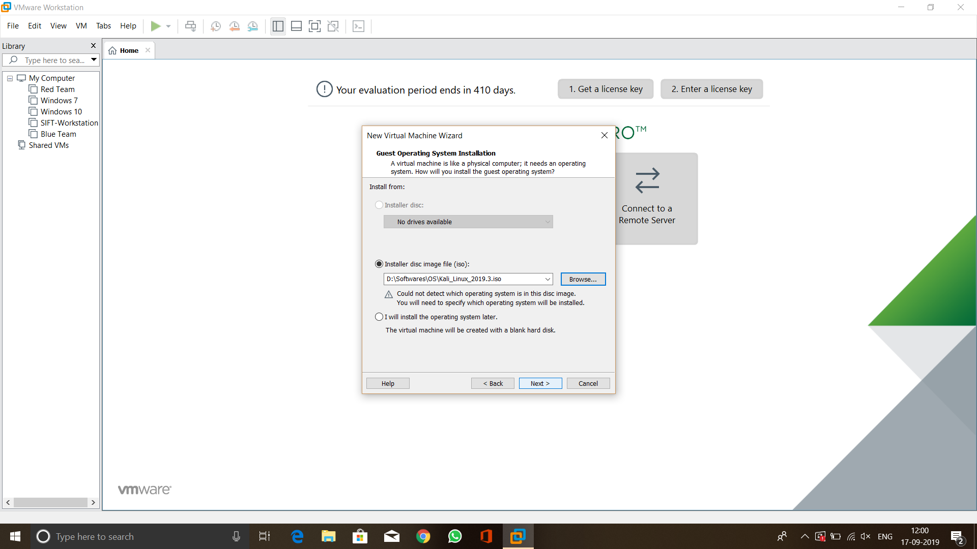

Figure Selection of ISO

Figure 4 elucidates how the menu looks like once the ISO file has been selected. Once I done this step, I have given **Next** option to proceed further.

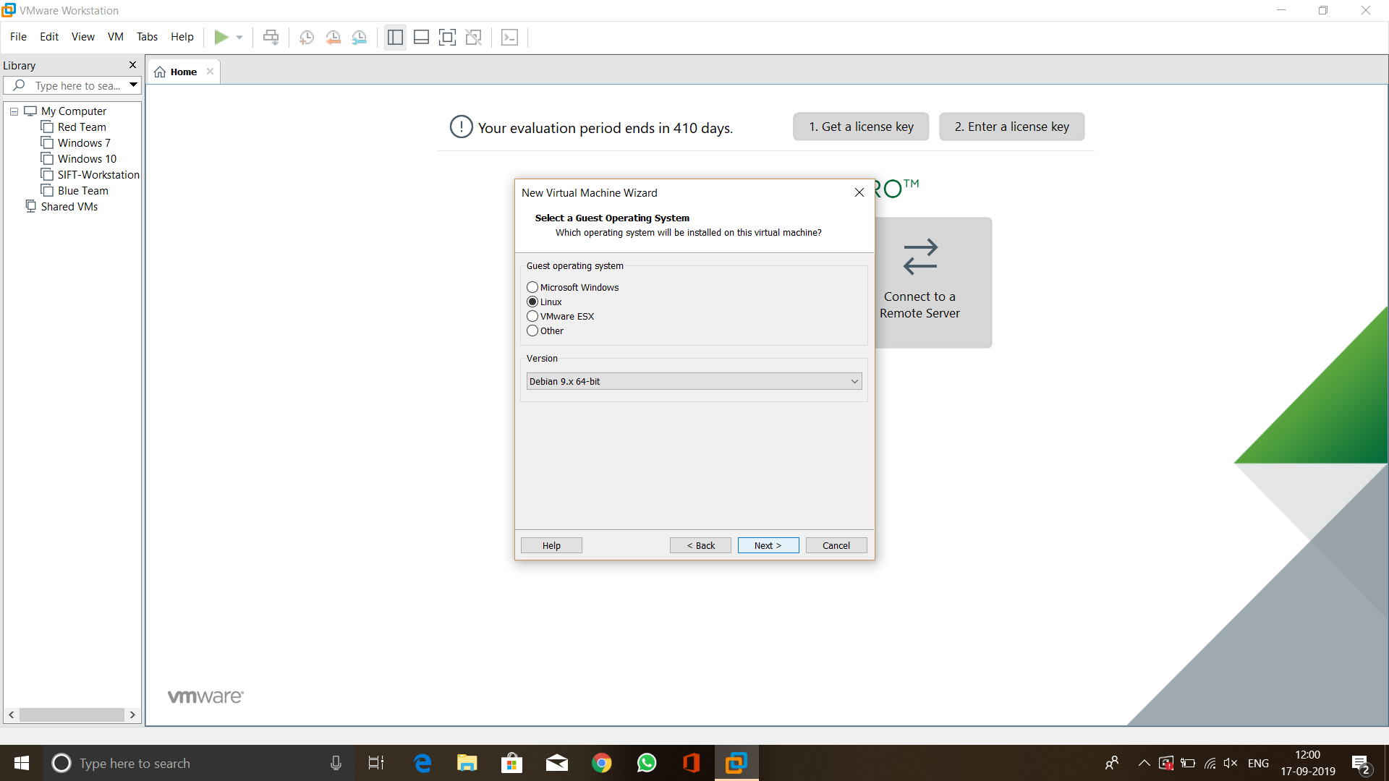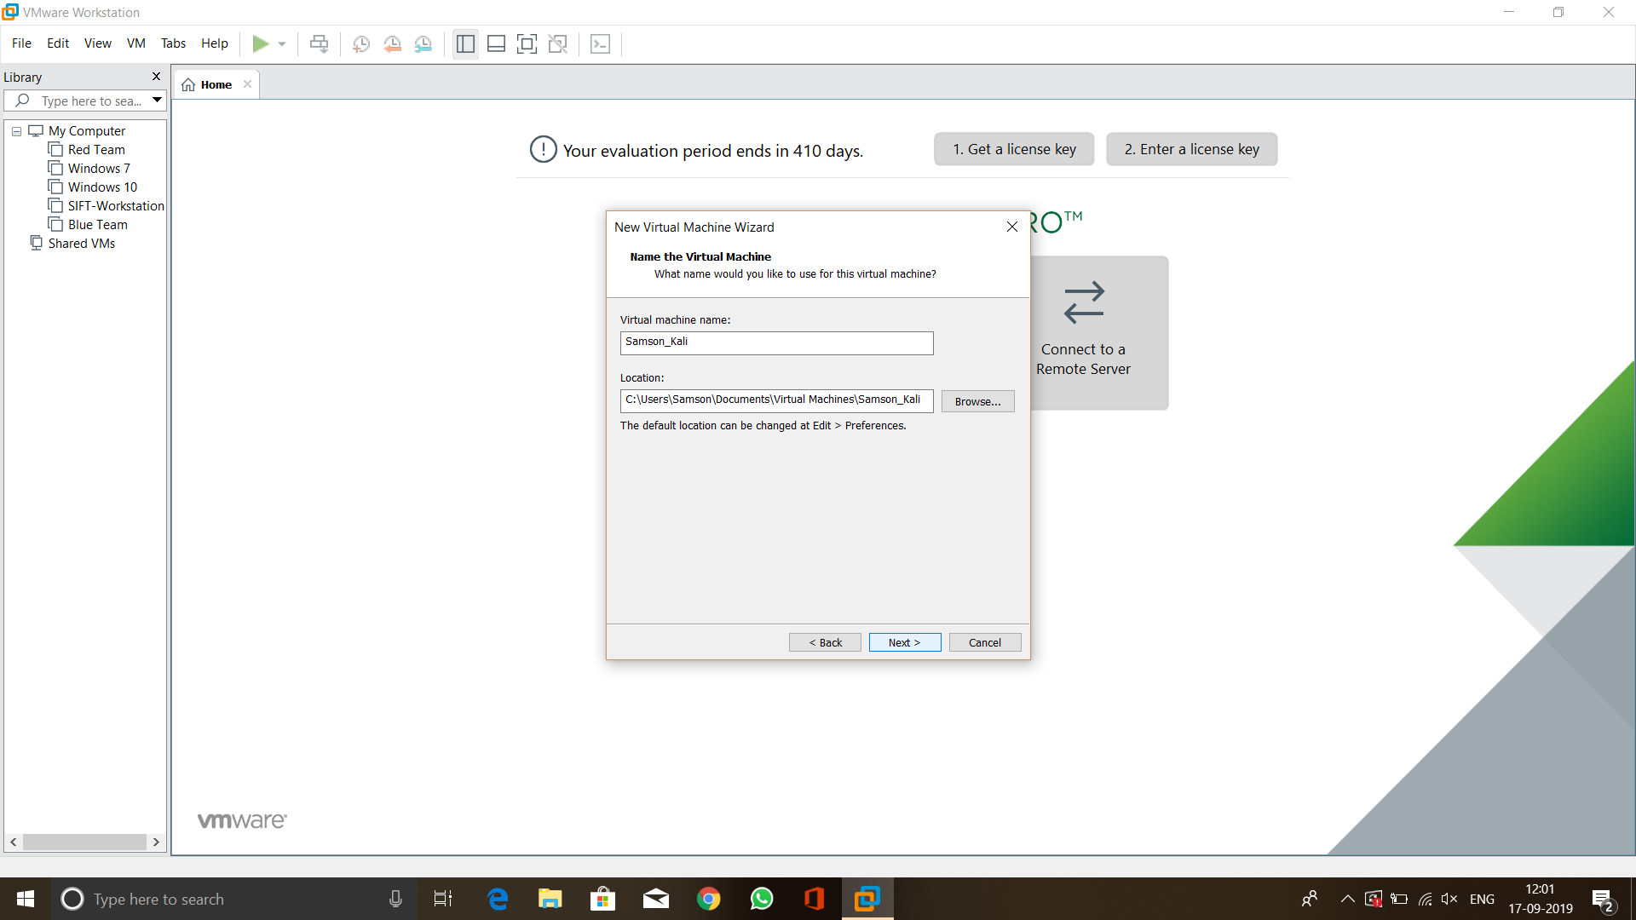

Figure Naming the VM Figure Selecting VM properties

Figure 5 shows selecting the VM properties. Since, Kali Linux is coming under Linux category and Debian type I have selected Linux and Debian 9.x. 64-bit. Figure 6 shows naming the VM I named it as Samson_Kali for easy identification of the VM. Once I have done this, I have selected Next option.

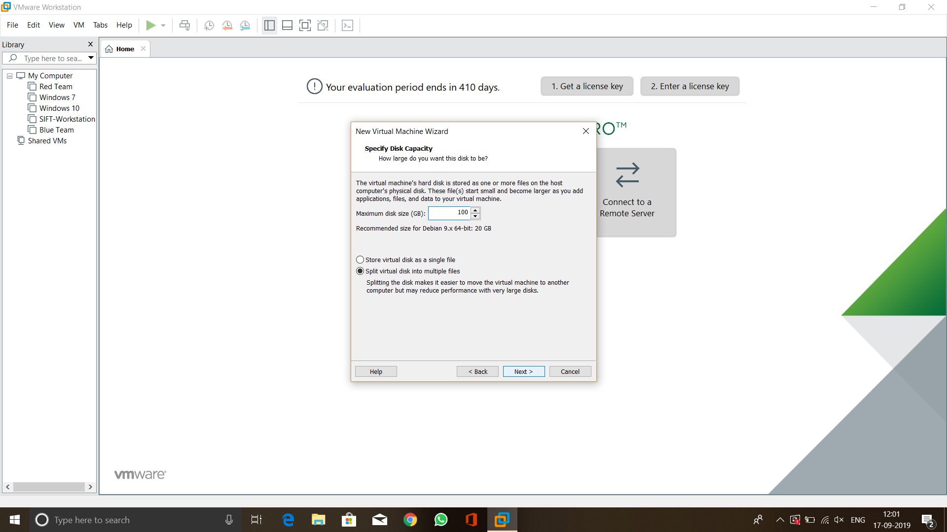

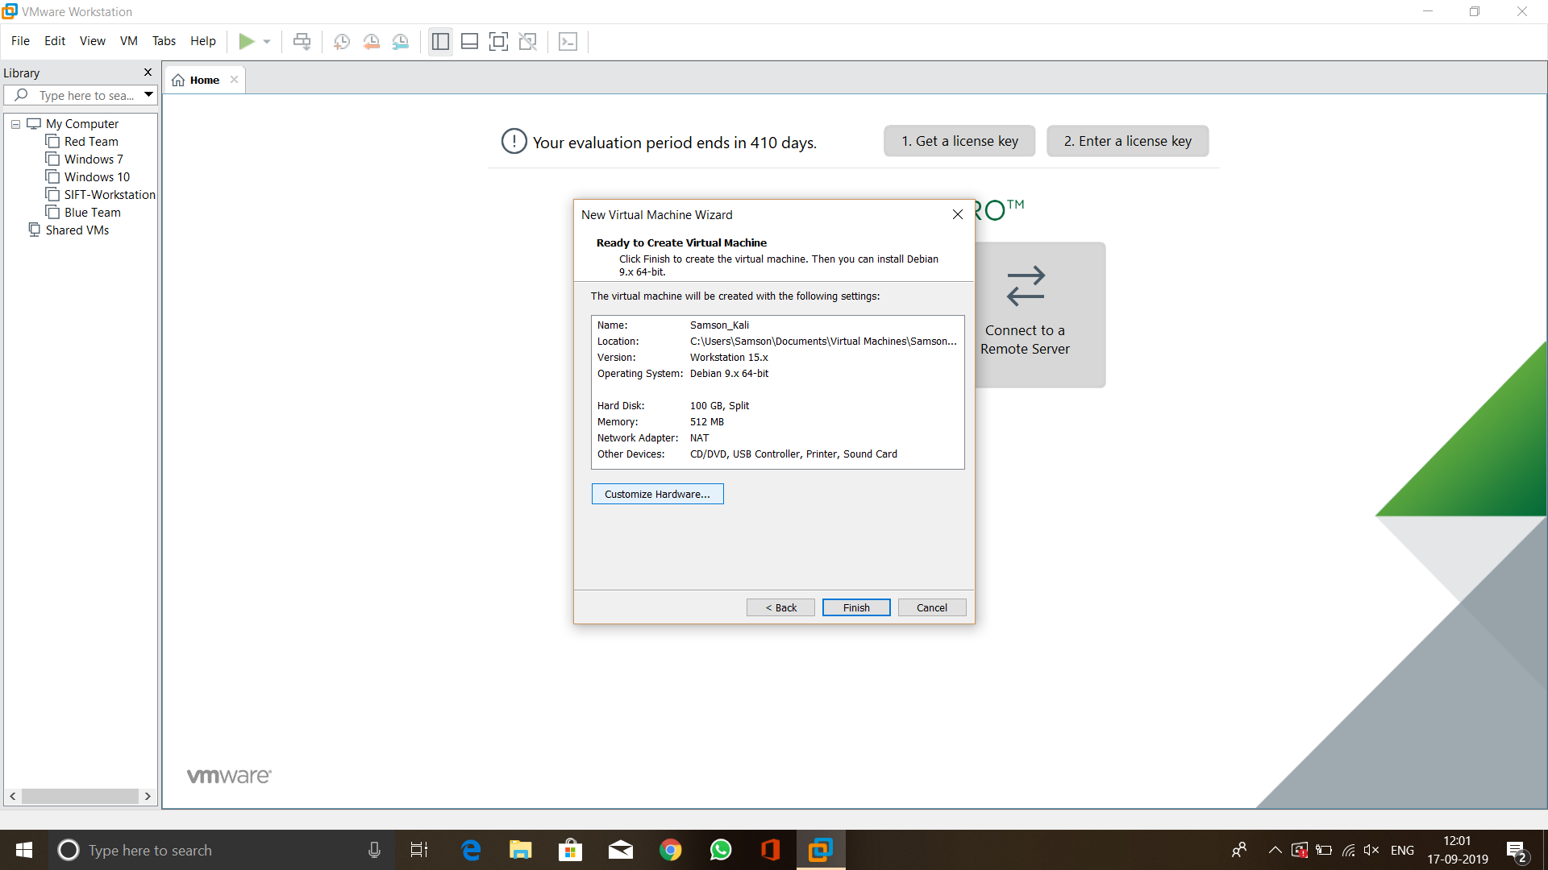

Figure Disk space

Figure 7 displays selection of disk space for my VM I have allocated 100 GB and then proceed further.

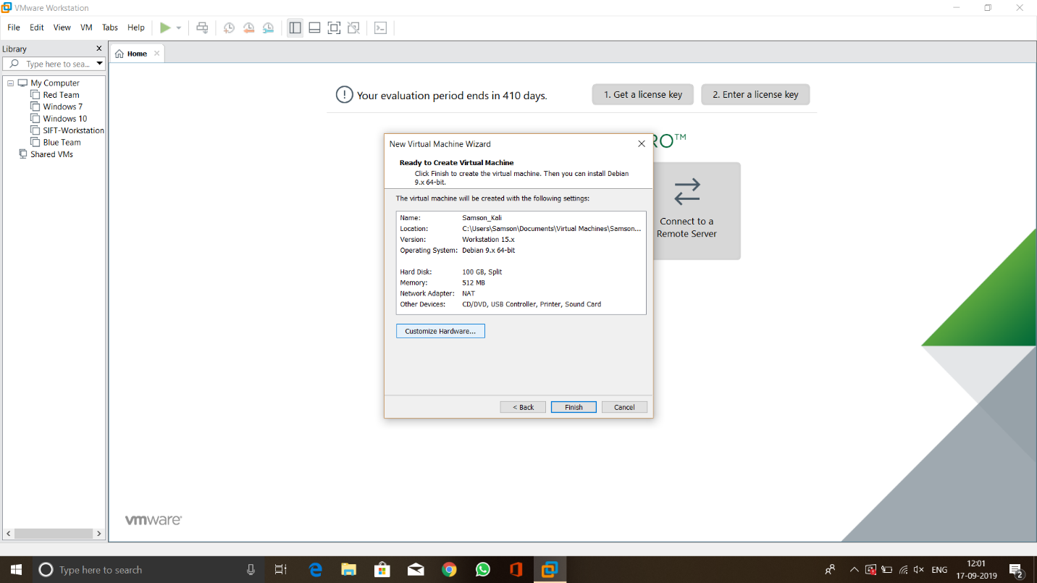 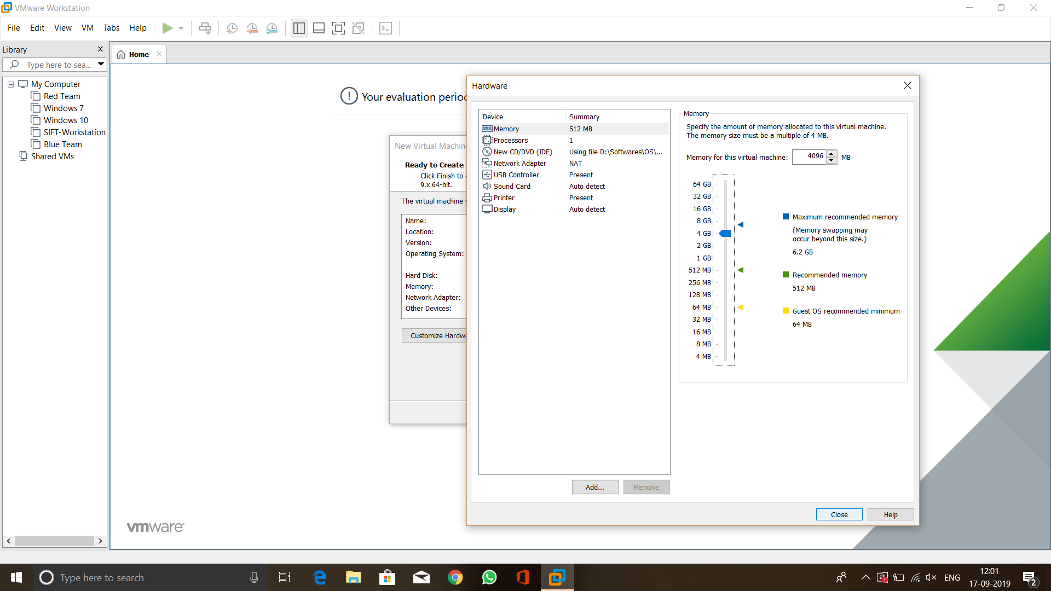

Figure Hardware Customization

Once hard disk space allocated I have used customize hardware and increased the amount of RAM to 4096 MB to increase the performance. This step has been given in Figure 8.

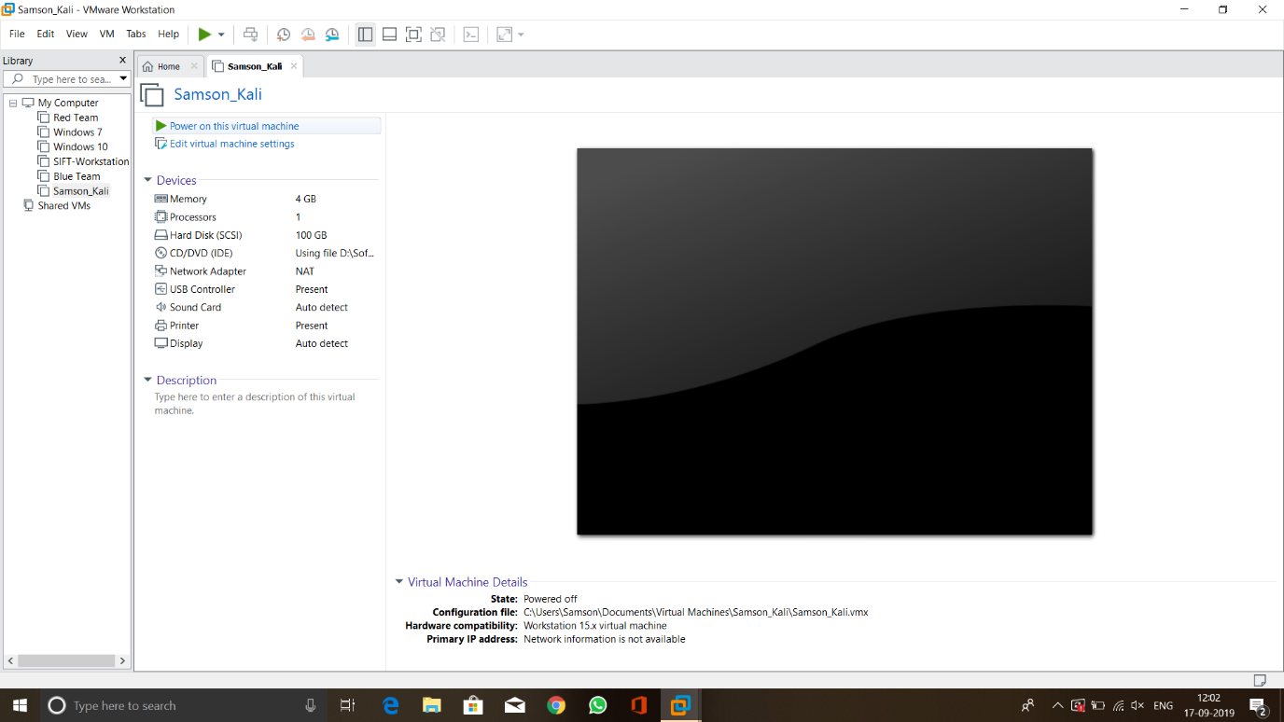

Figure Powering the VM on

Once the customization is over I just powered the VM on. This step has provided in Figure 9.

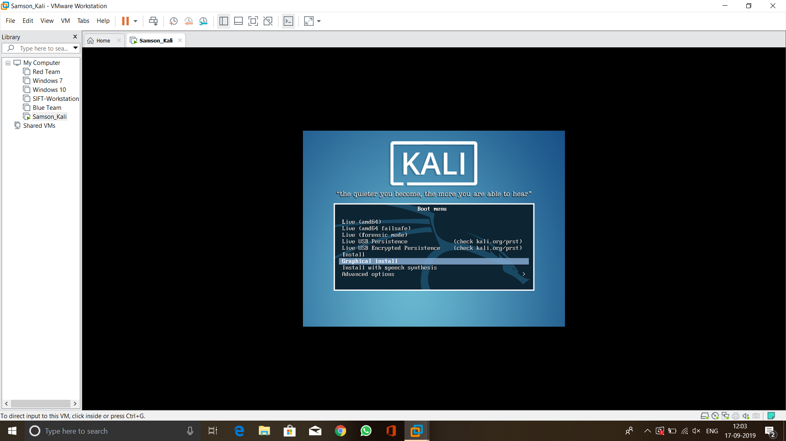

Figure Installing the OS

Figure 10 shows the home page of Kali Linux. In here I have chosen graphical install to start the installation process.

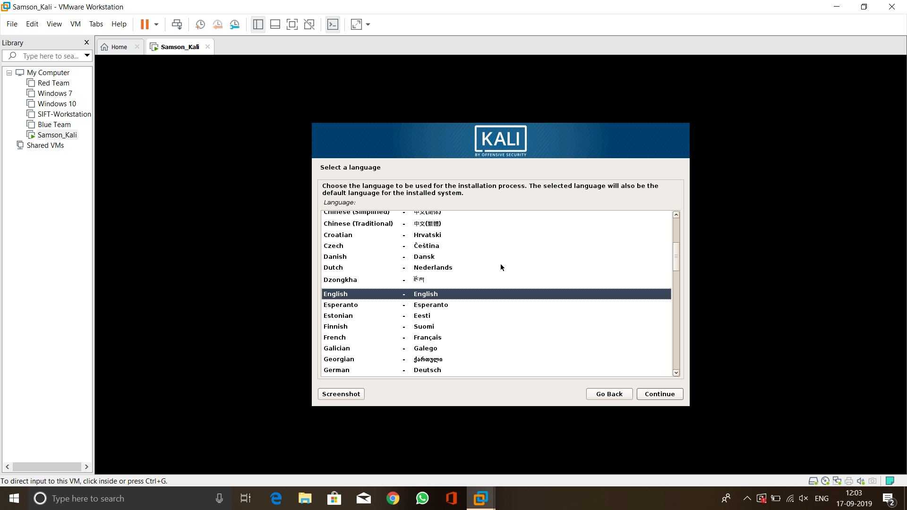

Figure Selecting language

Figure 11 shows that, the installation process started with selecting the language, here I have selected English as system language. Once it done I have selected continue to move further installation process.

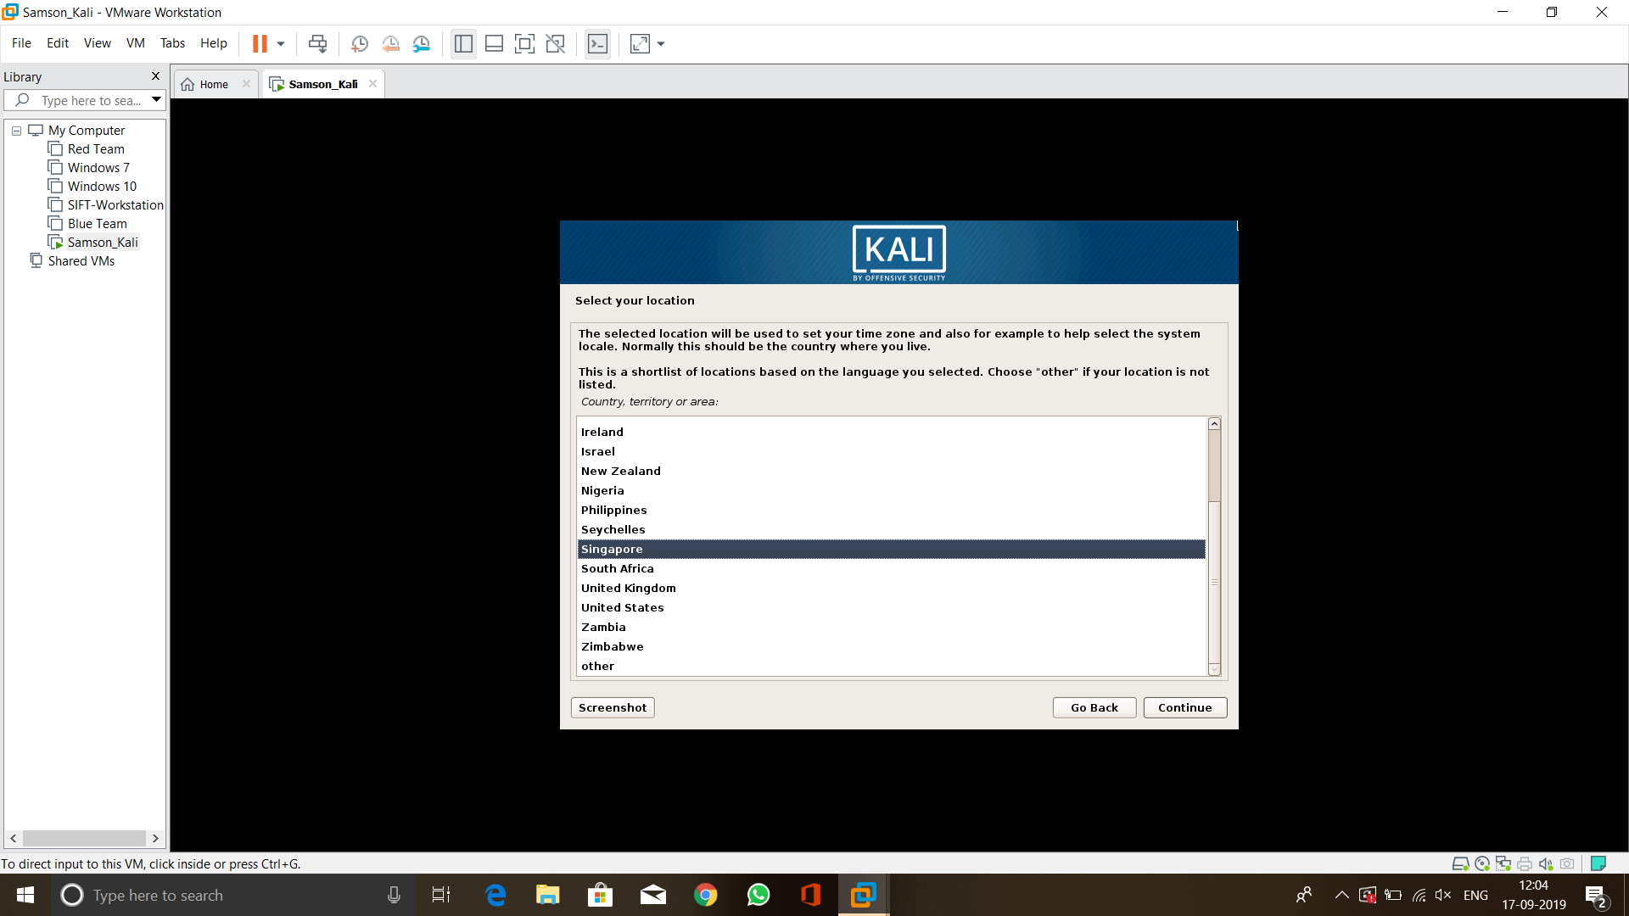

Figure Location selection

Figure 12 elucidated the selection of Geography location here I have selected Singapore which is my current location. Then clicked continue.

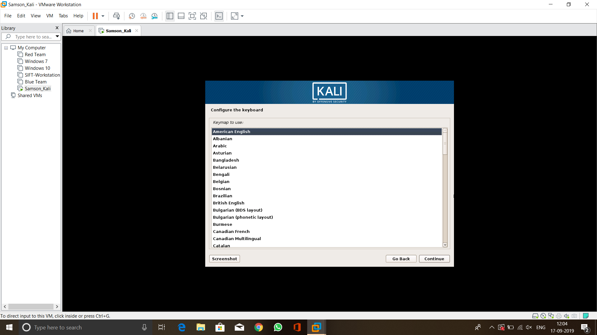

Figure Keyboard Layout

After selected the location I had chosen American English keyboard layout, which is given in figure 13.

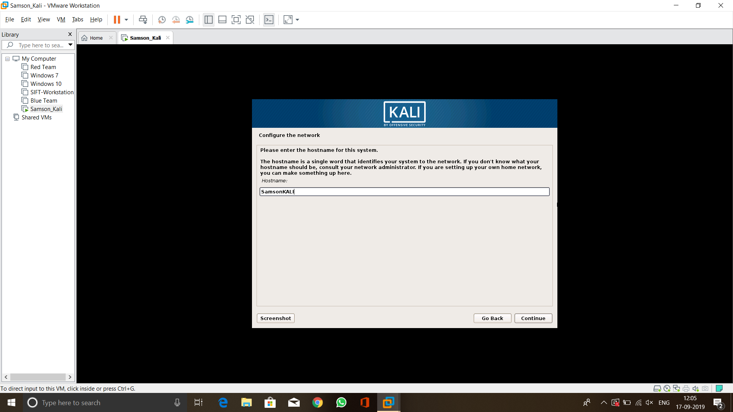

Figure Assigning Host name

After selected the keyboard layout I had set the hostname to Kali VM. The name I chose is SamsonKALI this step is given in figure 14.

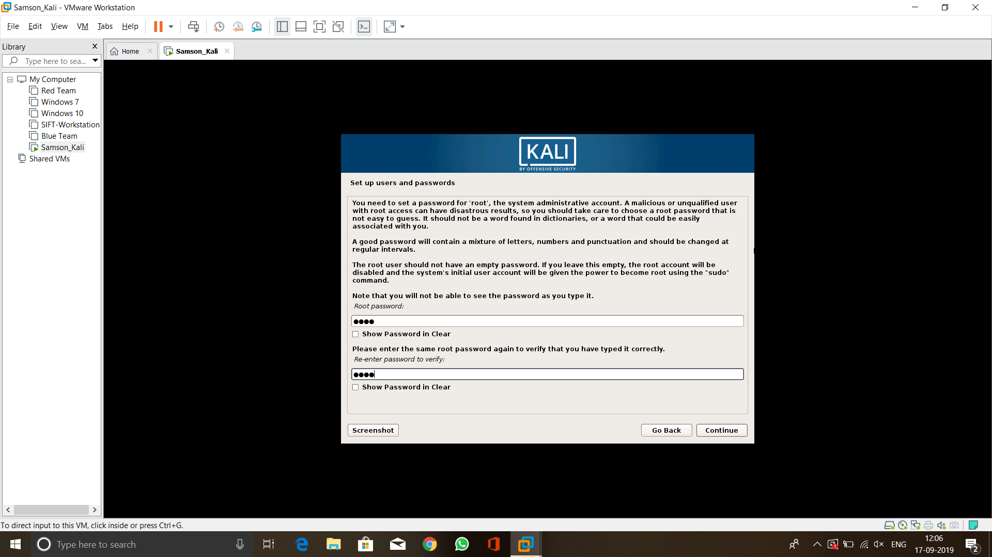

Figure Setting Password

Figure 15 shows configuring the user password and root password for the Kali VM. Root password is the one which provides access to all the services that runs in Linux distributions.

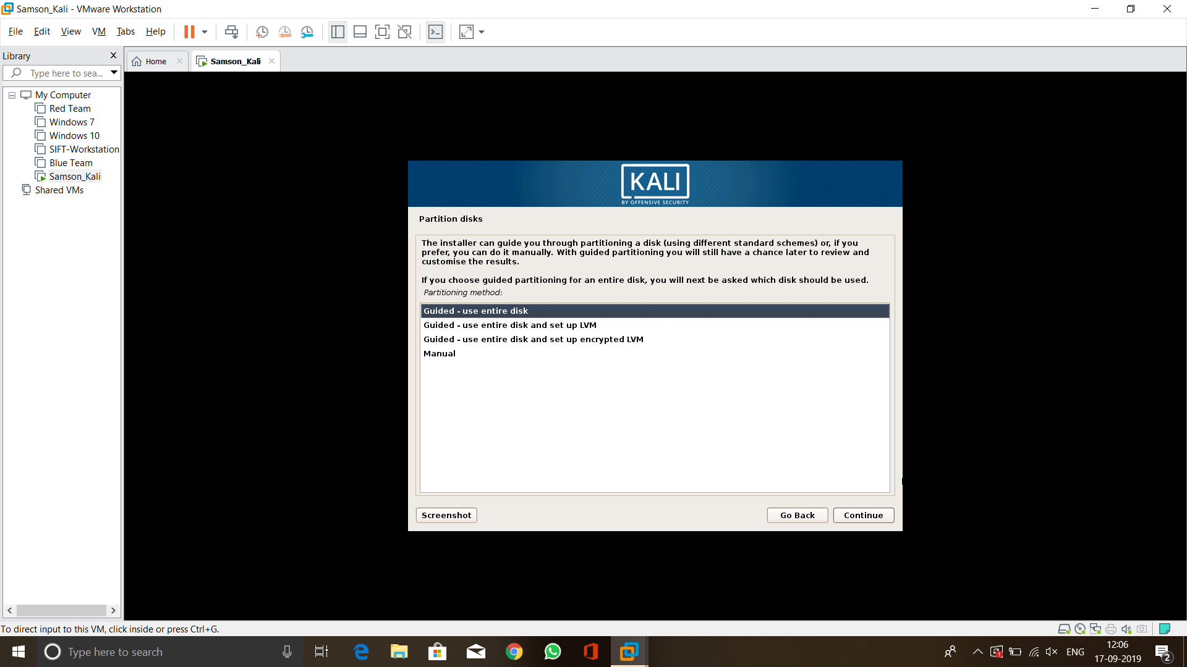

Figure Disk Partition

Once the user configuration part is done, I have prompt to partition disk option. Here, I have selected **Use entire disk** option to use entire disk to store the VM. This step had been given in Figure 16.

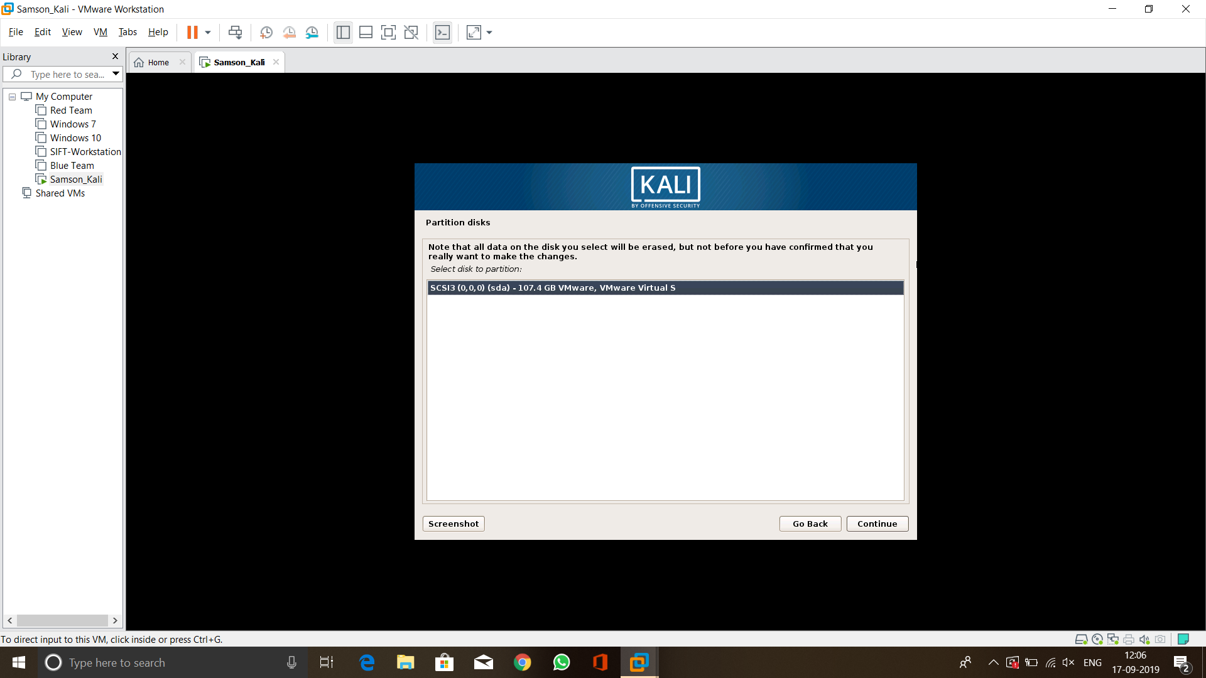

Figure Disk Partition cont...

Figure 17 shows the disk name and size that Kali VM going to get stored. The hard disk type used here is sda.

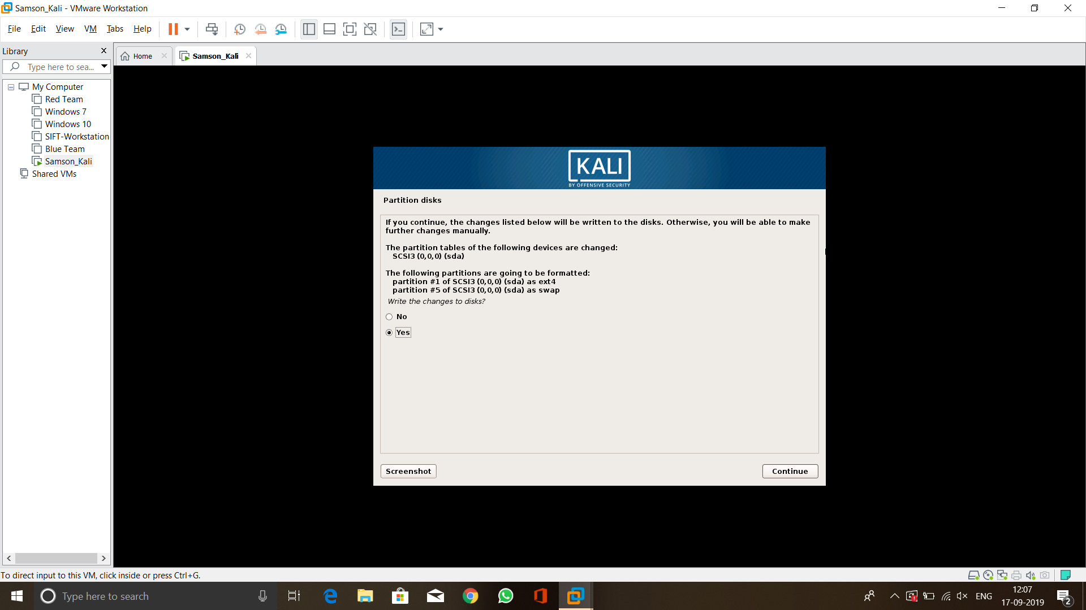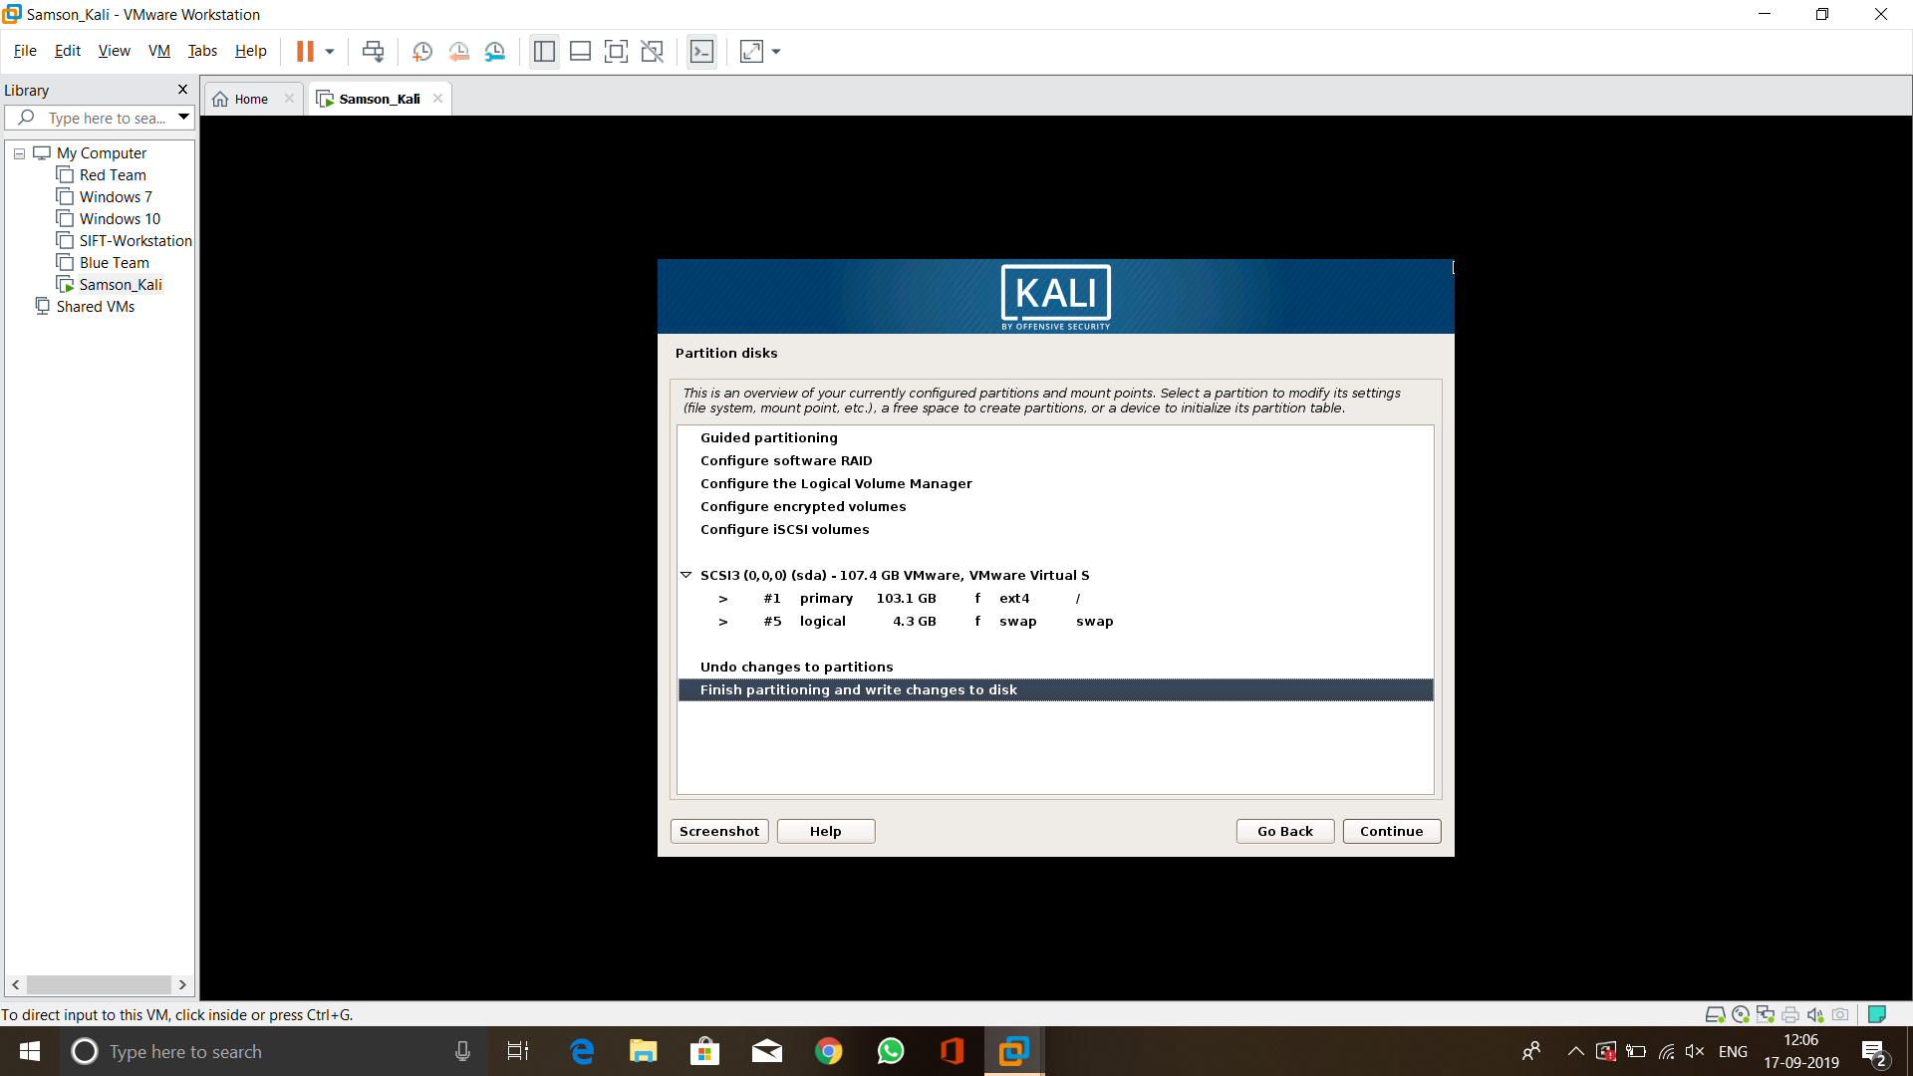

Figure Saving changes

Figure 18 shows selecting finishing the installation part. The main reason for this step is to save the installation in the selected disk. By doing this step the system can directly load the OS from the disk.

Once this process is done VMware powered the VM on. Once it started, I have entered the login credentials to login. The screenshot is given in Figure 19.

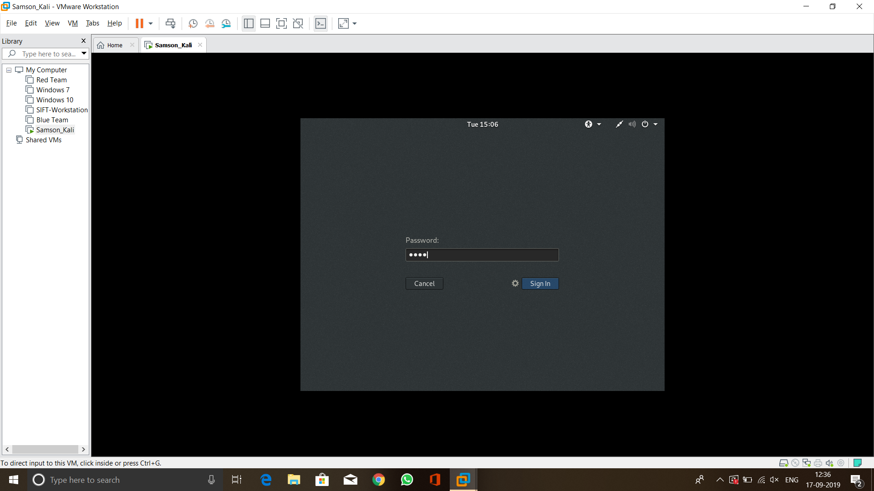

Figure Logging into system

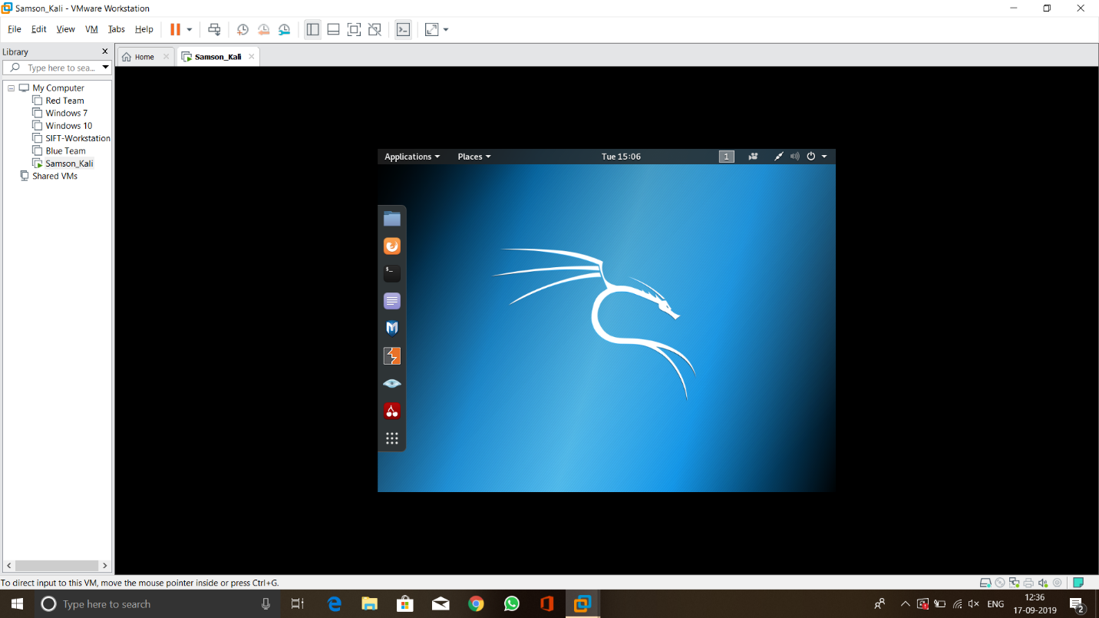

Figure Kali Linux Homepage

Figure 20 elucidates the homepage of Kali Linux. The tool bar consists the option to let access all the tools that are required for several security purposes like Penetration testing, Forensics, reverse engineering.

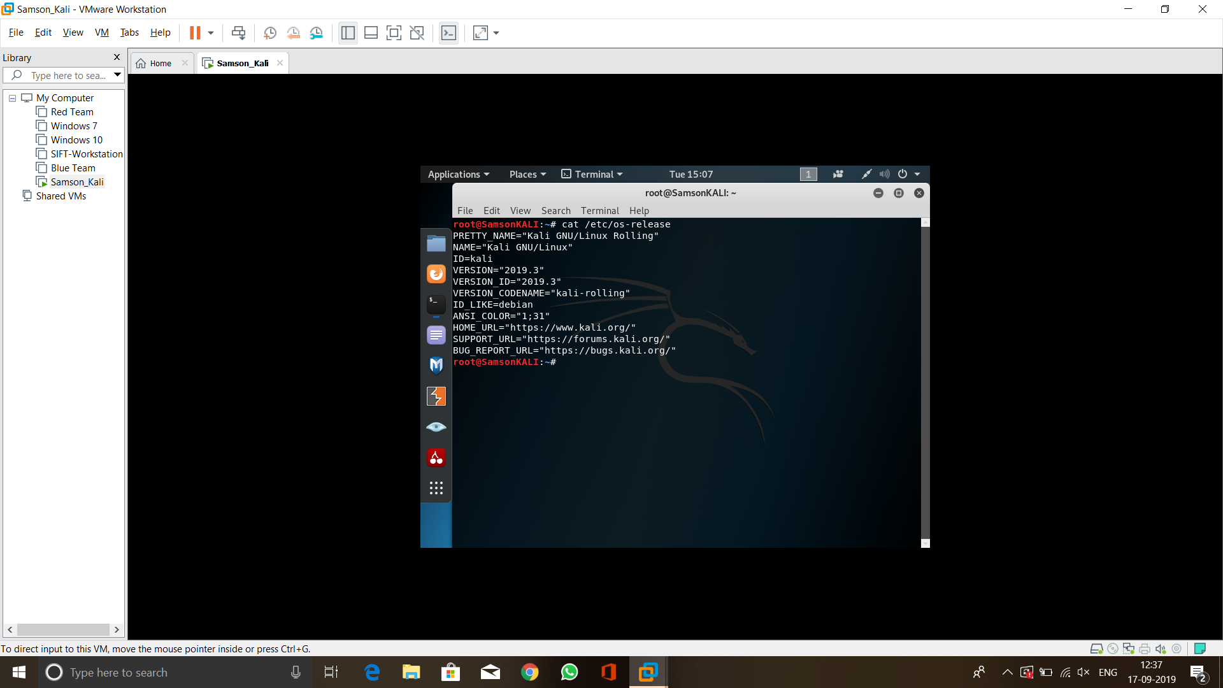

Figure Checking version

Once the Kali Linux loaded, I have entered the command **cat /etc/os-release** to check Kali Linux version. As the figure 21 shows it displayed the version which is 2019.3

# Step 2 creating server VM

For the server VM I have chosen to use Ubuntu. The detailed installation procedure had been given with screenshots.

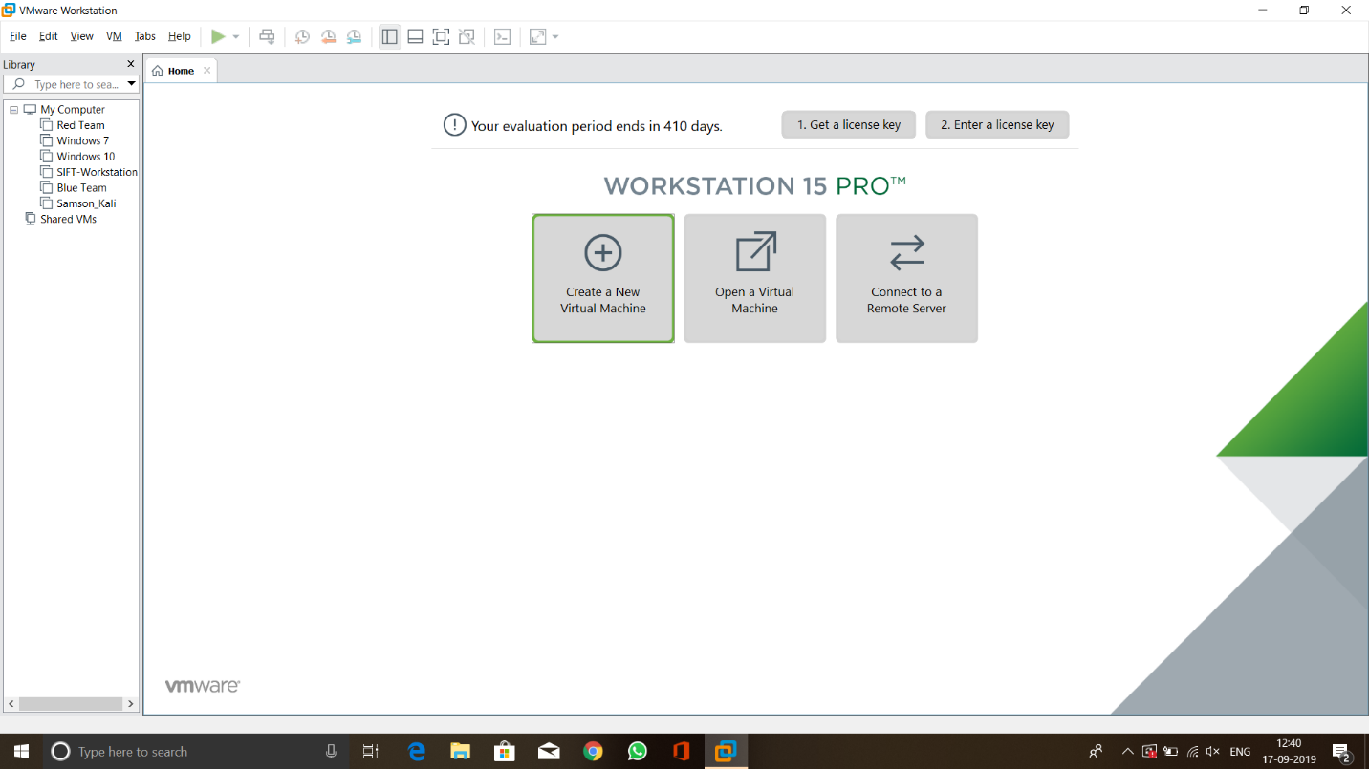

Figure Creating New VM

Figure 22 shows the starting of the procedure. Here have to select **“Create a new Virtual Machine”** option to get started.

Once, it started I had selected typical installation type from the menu where the screenshot is given in figure 23.

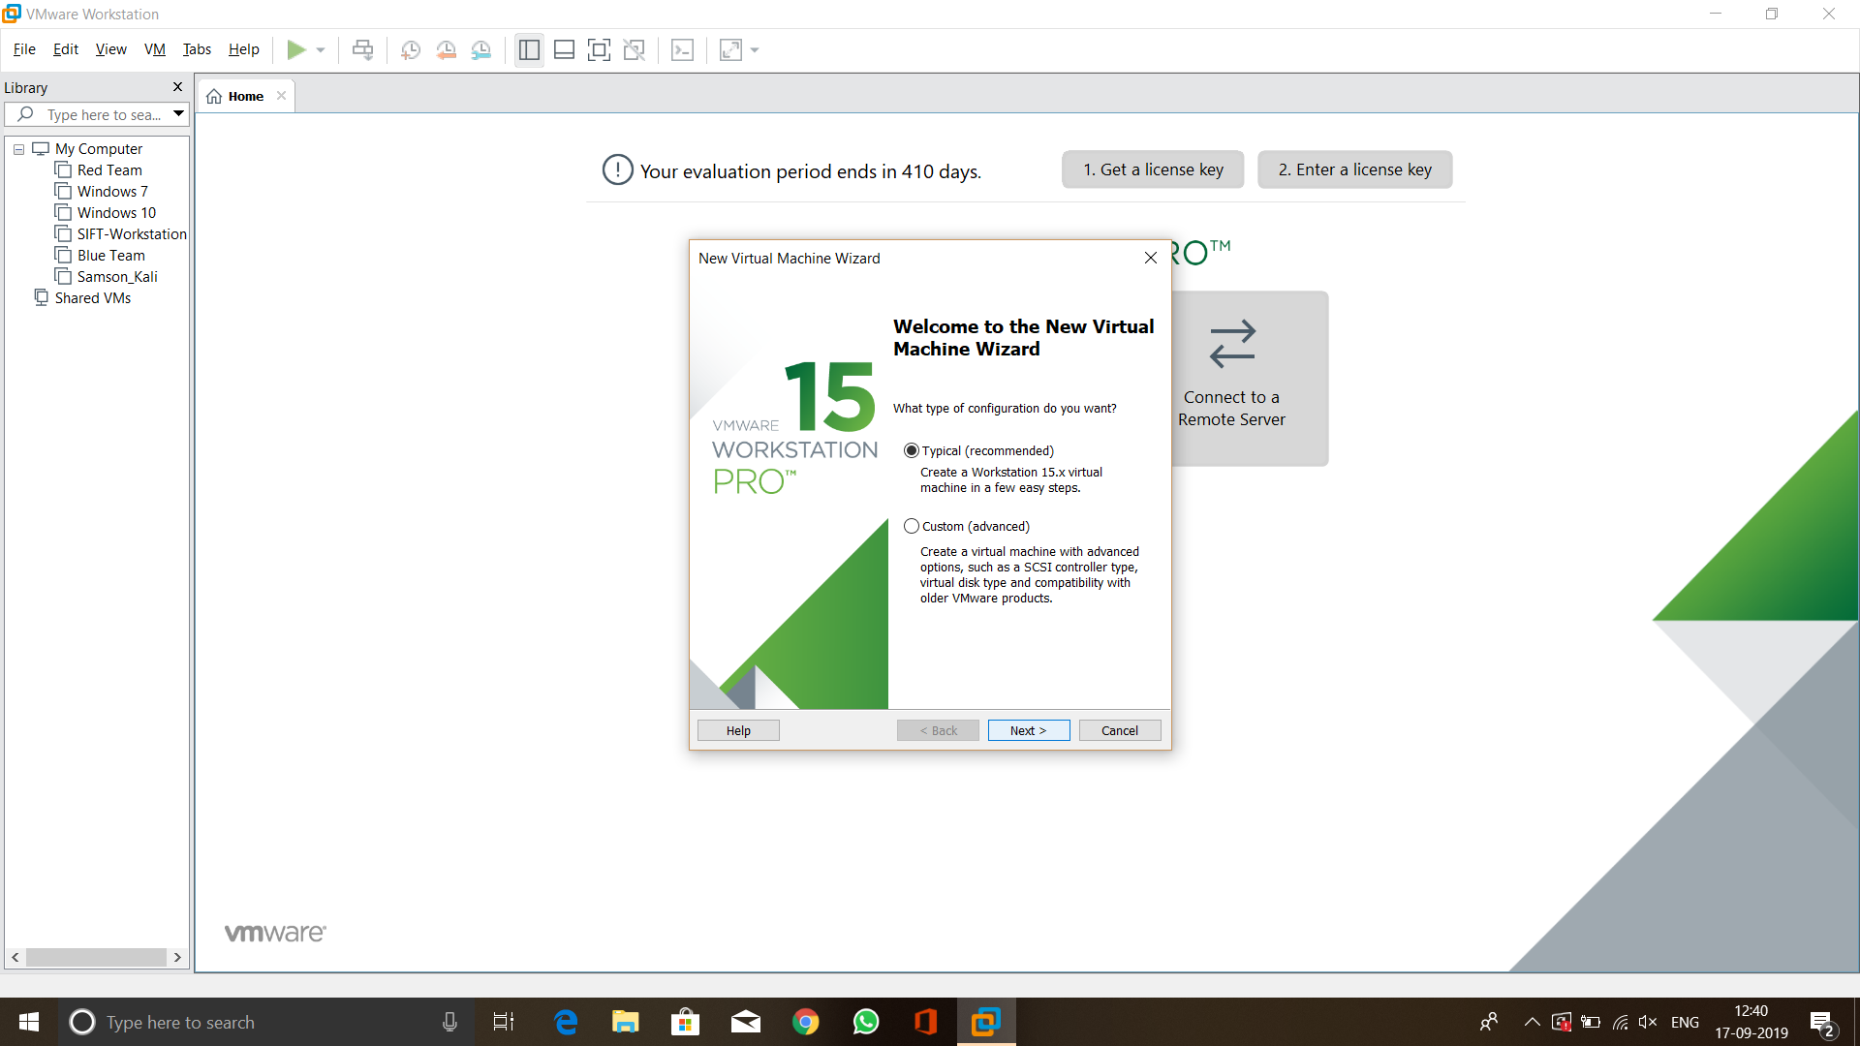

Figure Installation type

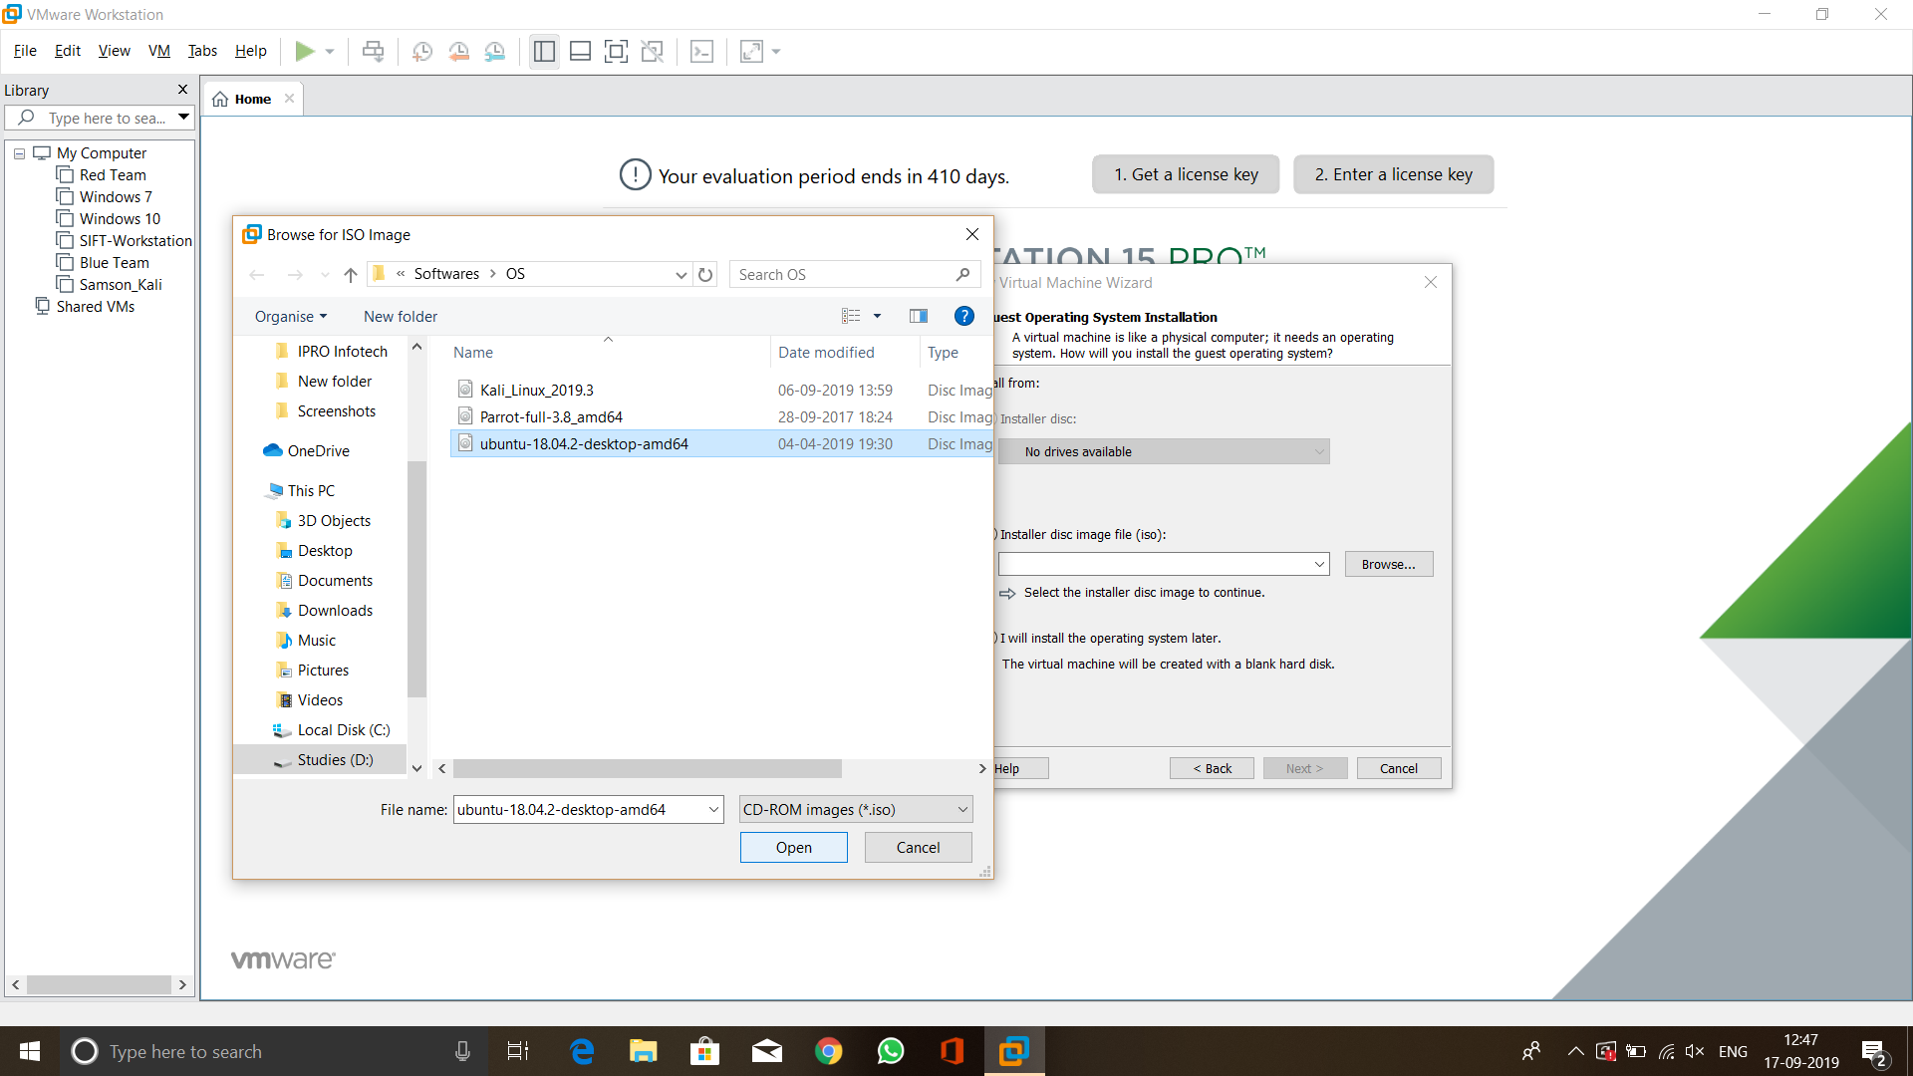

Figure Installation ISO

Figure 24 elucidates the selection of server VM ISO file from its folder.

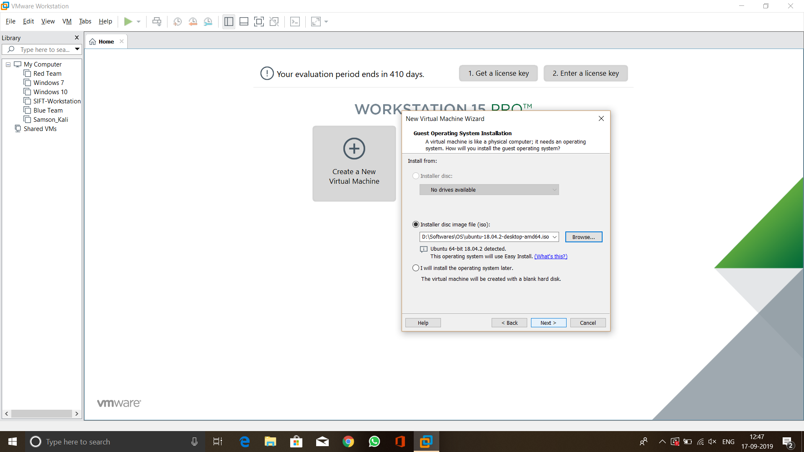

Figure Easy Install

Once the ISO file selected the dialog says **This operating system will use easy install** which means the entre installation process is automated where we need to provide only basic information. This had given in Figure 25.

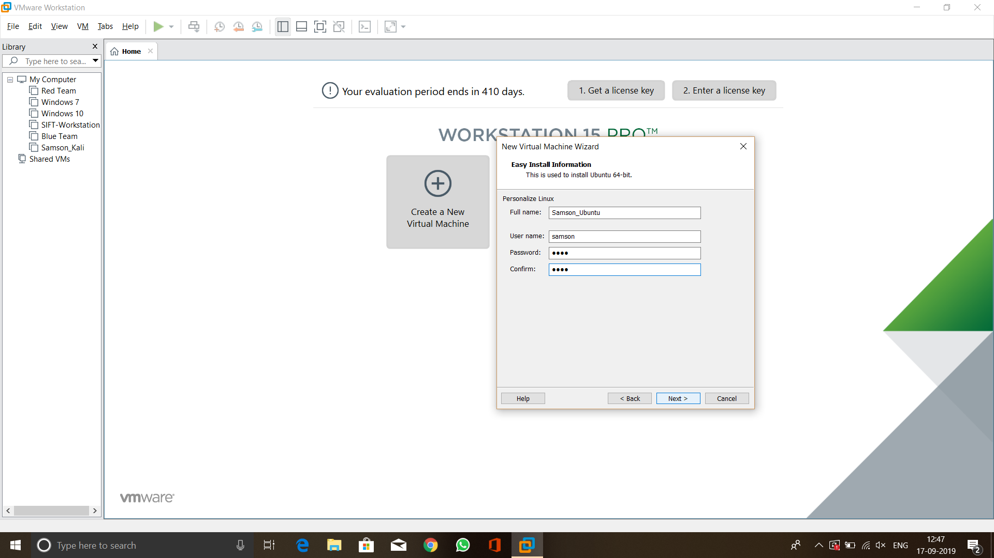

Figure Information to install

Figure 26 shows the information required to perform the easy install (automated install). Here as full name I have given Samson_Ubuntu, and as username I have given samson along with password. Then proceed next.

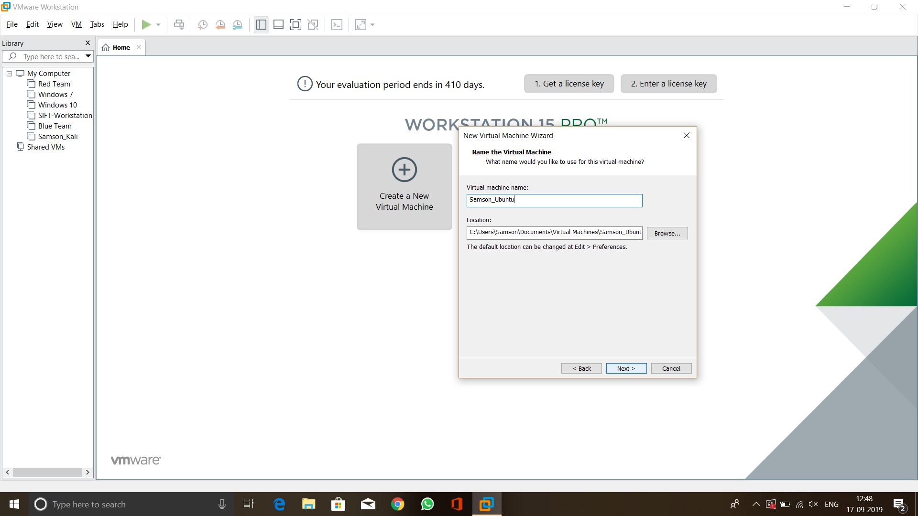

Figure VM Name

Figure 27 shows that I have entered **Samson_Ubuntu** as Virtual name. The reason is to show I am the user of this VM.

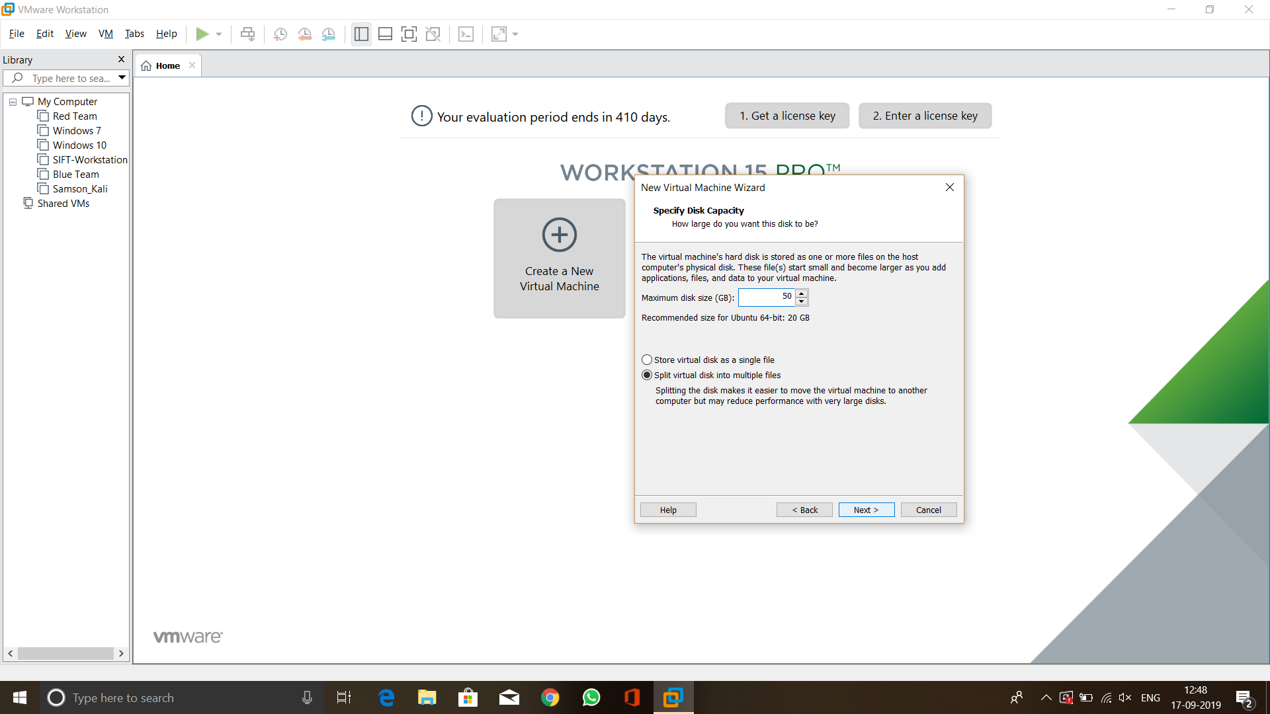

Figure Disk Capacity

After the user name process over I had specified the disk capacity. Here I have allocated 50 GB space for this Server VM. This step given in Figure 28.

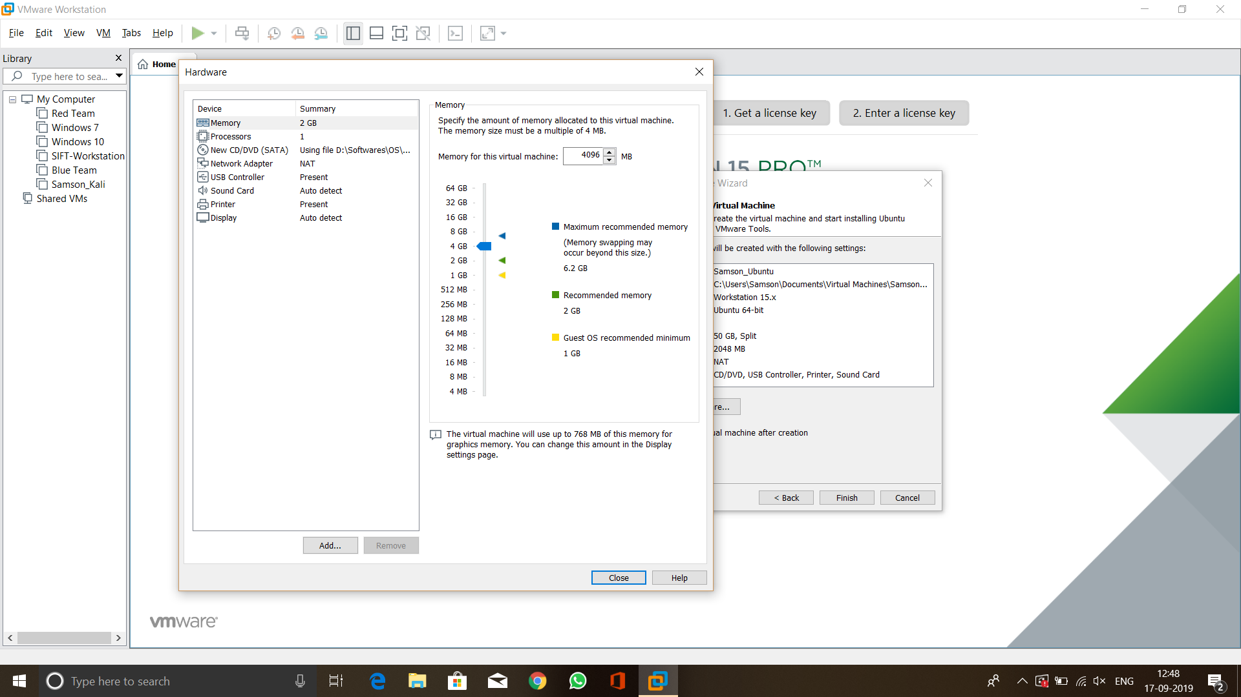

Figure Memory allocation

Figure 29 elucidates that the memory for this VM is increased from 1 GB to 4 GB to provide better performance.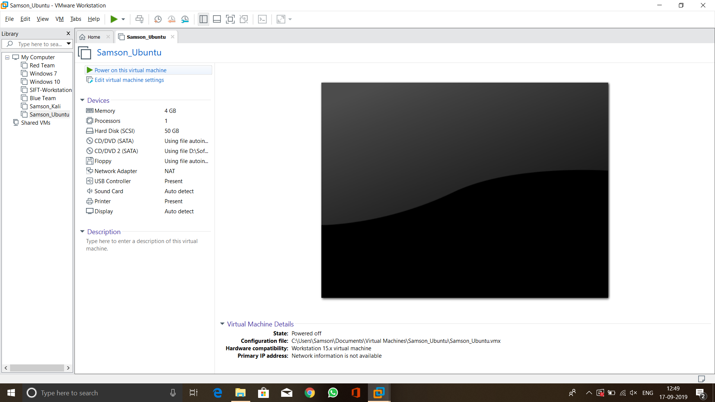

Figure Turning the machine ON

After Memory allocation just powered the VM on using the option **“Power on this virtual machine”.** This step is given in Figure 30.

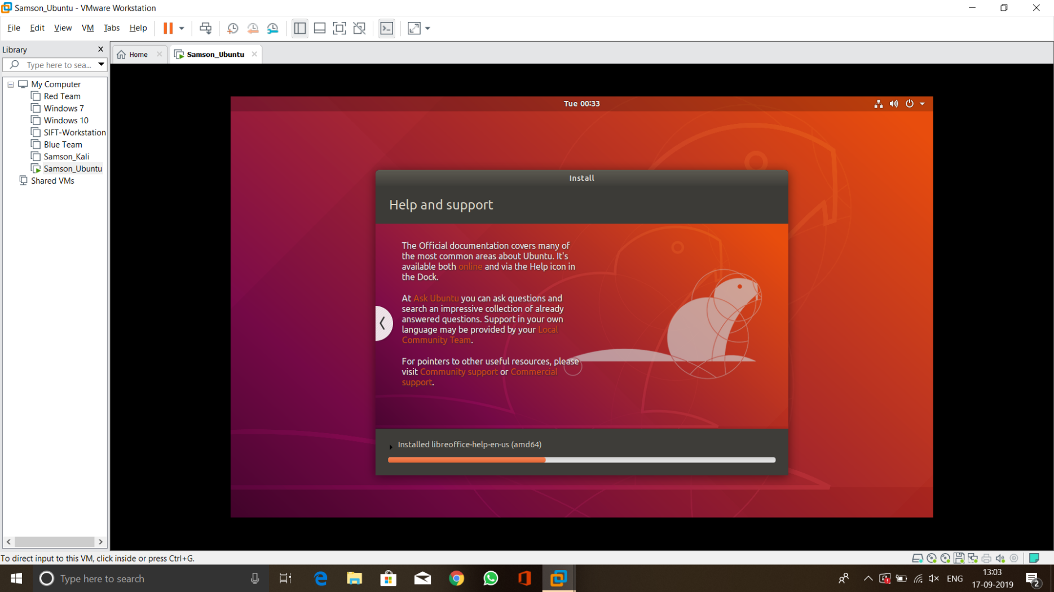

Figure Easy install

Since the VMware used easy install for this OS the entire installation process got fully automated and completed within few minutes, Figure 31 shows how the easy install is being used.

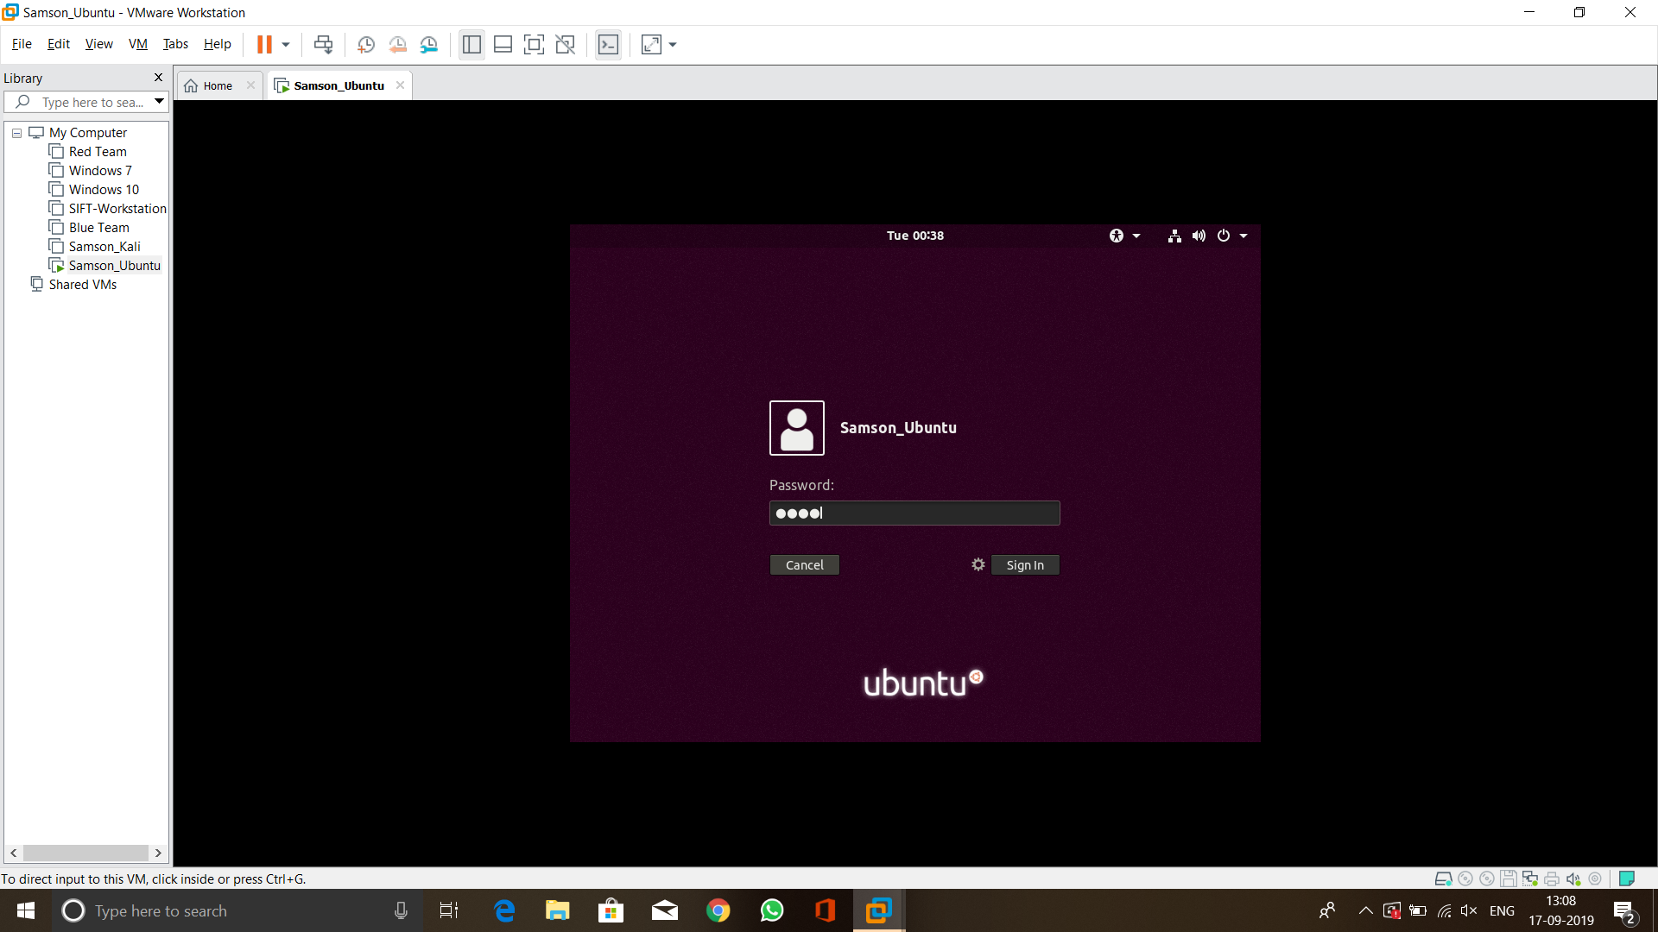

Figure Logging into the system

Figure 32 shows the logging into the ubuntu system after the instllation process is completed. Here the user name is Samson_Ubuntu and logged in using the credentials provided below.

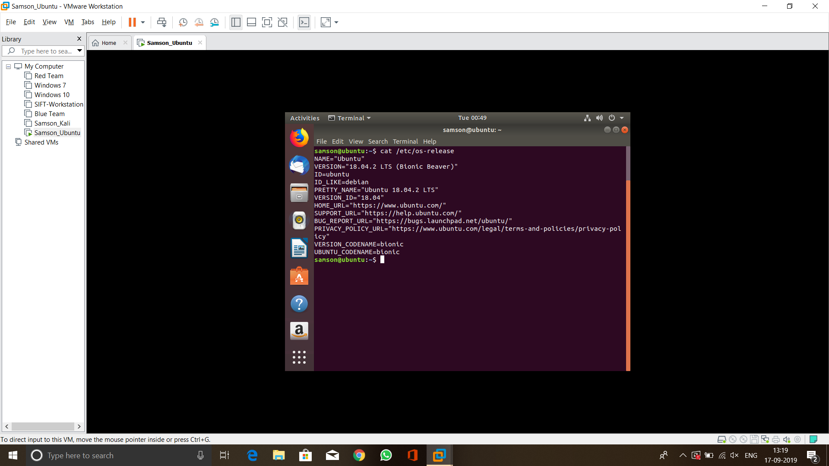

Figure Checking version

Once logged into the system I used the command **cat /etc/os-release** to see the version and it displayed the version I installed which is Ubuntu 18.04.2 LTS. This is given in Figure 33.